Analysis

From Aisle to Algorithms: International consumer in the age of Agentic AI
25 March 2026 , 3 mins read
Tech & Durables (T&D) is entering a new phase defined by intentional consumers and accelerated digital transformation. After years of economic and supply-chain disruptions, shoppers have become more value-driven, selective, and digitally empowered across every step of the journey.
Between FY 2025, global T&D turnover climbed to 857 Bil (+5% YOY), signaling not just recovery but a shift toward smarter, research-led purchasing powered by AI and omnichannel discovery. As consumers adopt agentic AI tools and demand clarity, trust, and convenience, brands must evolve to meet expectations shaped by data, transparency, and seamless digital engagement.


The Rise of the Intentional, Value-Centric Consumer
Consumers are no longer passive participants in the purchase journey. They are informed, empowered, and strategic.
Since 2019, average T&D prices have risen +26.2%, shaped by supply volatility and premiumization trends. Yet consumers are not chasing the lowest price, they are seeking trust, durability, convenience, and long-term value.
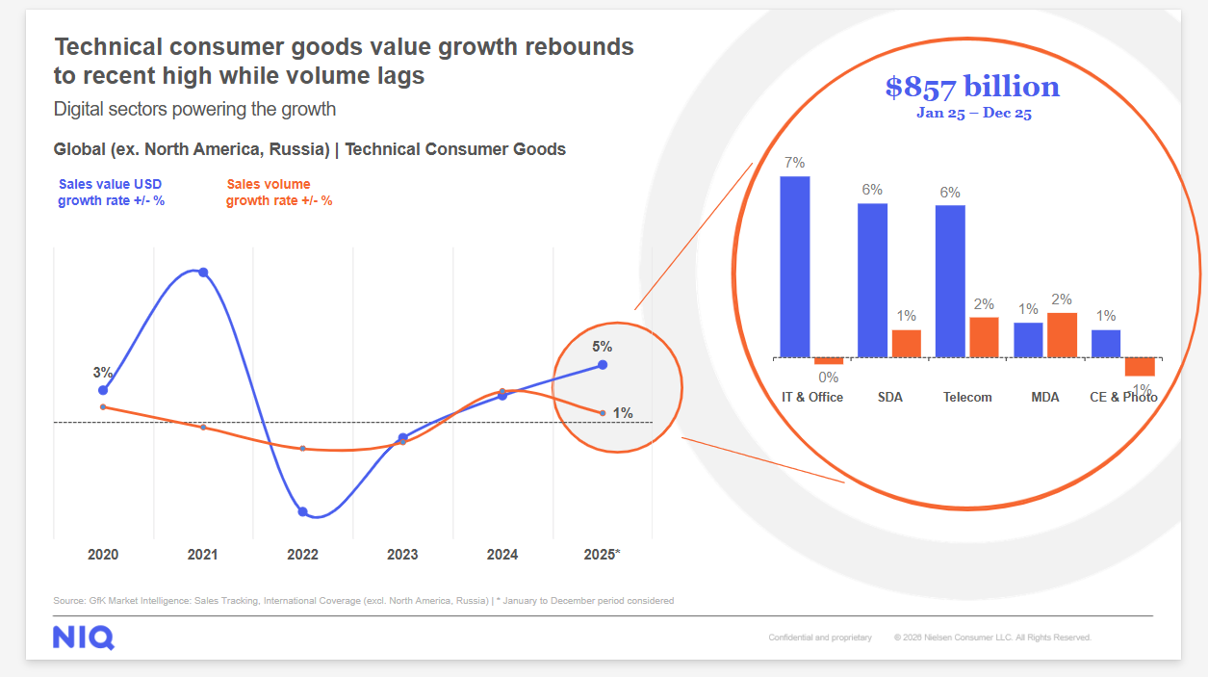
- 35% of annual TCG revenue in key categories comes from top 7 promotional events held across 15 weeks.
- Consumers want clarity, confidence, and convenience throughout their journey. Omnichannel research, verified reviews, warranties, and post-purchase support increasingly define trust.
- Value seeking goes mainstream, consumer choosing refurbish products over new products

“Consumers’ intentions are shaped by whoever provides the simplest, clearest, most credible path to decision-making.”

Nevin Francis, Senior Director Global CS Thought Leadership Team

Agentic AI and the New Multi-Touchpoint Journey
The path from “I want” to “I own” is now fast, fluid, and deeply digital. AI is transforming research, comparison, and purchasing experiences. Consumers expect personalized, time-saving guidance, often automated.
Retailers leverage AI for dynamic pricing, promotions, inventory optimization, and personalized engagement. Meeting these diverse demands at scale requires a robust foundation of technology and data. AI is moving beyond buzzword to become a core enabler of transformation in retail and manufacturing.
As agentic AI becomes mainstream, brands must design experiences that appeal not only to consumers but to algorithms acting on their behalf.
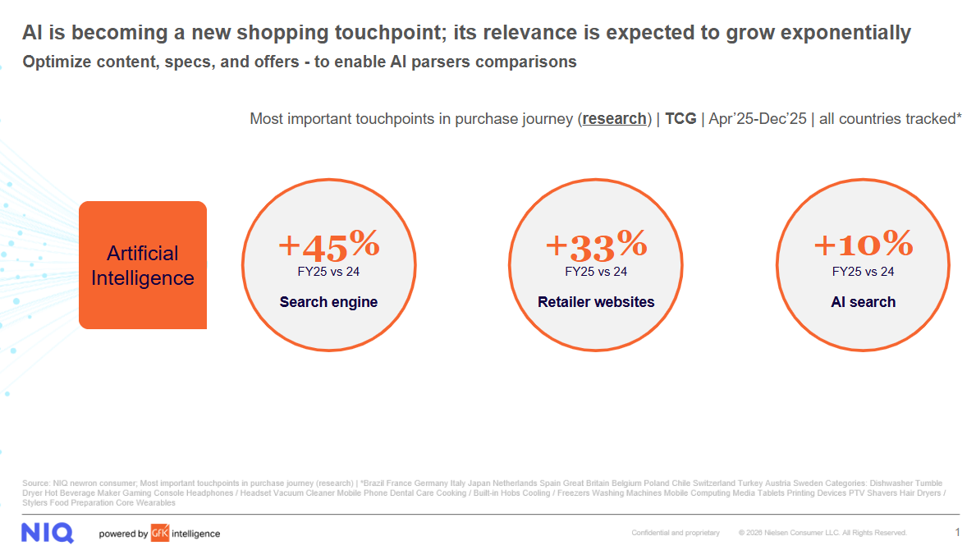

“AI is transforming the consumer journey from discovery to loyalty – delivering personalized, timesaving experiences.”

Nevin Francis, Senior Director Global CS Thought Leadership Team

Challenger Brands, Fragmented Demand & Retail Shifts
Competitive pressure continues to intensify, particularly in China’s brand-driven segments.
Challenger brands capture 22% of Telecom and 11% of Major Domestic Appliances due to cost advantages. In Small Domestic Appliances, innovation and speed of change gives challengers 8% market share.
Retail ecosystems too are becoming more fragmented; marketplaces, D2C, social commerce, and quick commerce increasingly shape discovery and influence purchase decisions.
Generational nuances amplify complexity: Gen Z relies more on social recommendations (+8.2% more vs. total population’s average) while Baby Boomers remain strongly brand-driven.
Personalization at scale is now a competitive advantage; AI is a key enabler.
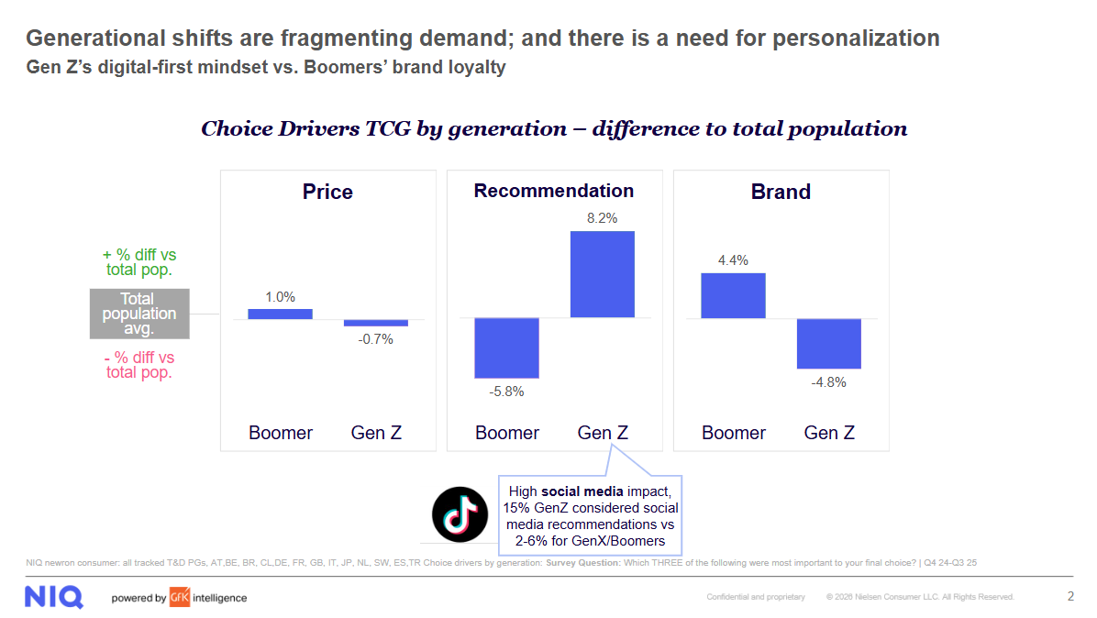

Outlook for 2026
Success in 2026 depends on aligning product, pricing, and experience strategies to intentional consumers and AI-driven purchase journeys. Geopolitical uncertainty can result in rising inflation for certain types of products and service. Plateauing growth in China will test tech and durables resilience, while extended Windows 10 support and sporting events could inject demand into computing and entertainment categories (especially TVs) respectively. Post pandemic demand could also kick-in for some kitchen categories across SDA & MDA. Innovation will remain in the lifeblood of Tech & Durables, but novelty alone won’t guarantee success.

Consumers, shaped by years of inflation, have become intentional and uncompromisingly value-centric. In 2026, Consumers will reward brands that pair breakthrough technology with clarity, convenience, and confidence.

